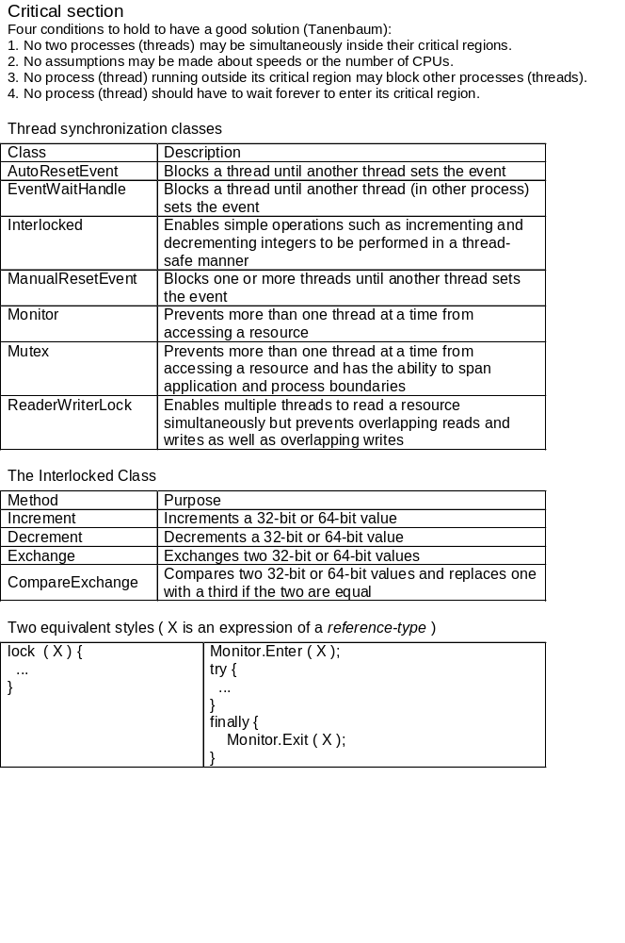

Mutex and Monitor
The word “mutex” is a contraction of the words “mutually exclusive.” A mutex is a synchronization object that guards a resource and prevents it from being accessed by more than one thread at a time. It’s similar to a monitor in that regard.
Two fundamental differences, however, distinguish monitors and mutexes: 1) When used to synchronize threads in the same application, mutexes are orders of magnitude slower than monitors. The real power of mutexes lies in reaching across application boundaries.
2) If a thread acquires a mutex and terminates without freeing it, the system deems the mutex to be abandoned and automatically frees it. Monitors are not afforded the same protection.

Waiting and Pulsing
Monitor includes static methods named Wait, Pulse, and PulseAll
- Wait temporarily relinquishes the lock held by the calling thread and blocks until the lock is reacquired.
- The Pulse and PulseAll methods notify threads blocking in Wait that a thread has updated the object guarded by the lock. Pulse queues up the next waiting thread and allows it to run when the thread that’s currently executing releases the lock. PulseAll gives all waiting threads the opportunity to run.

Events
- Whereas monitors, mutexes, and reader/writer locks are used to guard access to resources, events are used to coordinate the actions of multiple threads in a more general way, ensuring that each thread does its thing in the proper sequence with regard to the other threads.
- As a simple example, suppose that thread A fills a buffer with data that it gathers and thread B is charged with the task of reading data from the buffer and doing something with it. Thread A doesn’t want thread B to begin reading until the buffer is prepared, so it sets an event object when the buffer is ready. Thread B, meanwhile, blocks on the event waiting for it to become set. Until A sets the event, B blocks in an efficient wait state. The moment A sets the event, B comes out of its blocked state and begins reading from the buffer.
- Windows supports two different types of events: auto-reset events and manual-reset events. The .NET Framework class library wraps these operating system kernel objects with classes named AutoResetEvent and ManualResetEvent.
- Both classes feature methods named Set, Reset, and WaitOne for setting an event, resetting an event, and blocking until an event becomes set, respectively. If called on an event that is currently reset, WaitOne blocks until another thread sets the event. If called on an event that is already set, WaitOne returns immediately. An event that is set is sometimes said to be signaled. The reset state is also called the nonsignaled state.

Interlocked
Atomic operations for 32-bit or 64-bit variables that are shared by multiple threads.

Add | Adds two integers and replaces the first integer with the sum, as an atomic operation.
CompareExchange | Compares two values for equality and, if they are equal, replaces one of the values.
Decrement | Decrements a specified variable and stores the result, as an atomic operation.
Exchange | Sets a variable to a specified value as an atomic operation.
Increment | Increments a specified variable and stores the result, as an atomic operation.
Read | Returns a 64-bit value, loaded as an atomic operation.

Sum = 1 + 2 + …. + 1000000000
שני חוטים מחשבים סכום משותף
First Thread Second Thread
1 + 2 + …. + 499999999 → commonSum ← 500000000 + 500000001 + ……+ 1000000000

class Program
{
private const long counter = 1000000000L, halfCounter = counter / 2;
private long commonSum = 0;

static void Main(string[] args)
{
Program myProgram = new Program();
Thread t1 = new Thread(myProgram.myFunction1);
//// Thread t1 = new Thread(new ThreadStart(myProgram.myFunction1));
t1.Start();
Thread t2 = new Thread(myProgram.myFunction2);
/// Thread t2 = new Thread(new ThreadStart(myProgram.myFunction2));
t2.Start();

while (t1.ThreadState == ThreadState.Running ||
t2.ThreadState == ThreadState.Running)
;
Console.WriteLine(myProgram.commonSum);
Console.Read();
}
public void myFunction1()
{
for (long i = 1; i < halfCounter; i++)
// commonSum += i;
Interlocked.Add(ref commonSum, i);
}
public void myFunction2()
{
for (long i = halfCounter; i <= counter; i++)
// commonSum += i;
Interlocked.Add(ref commonSum, i);
}
}
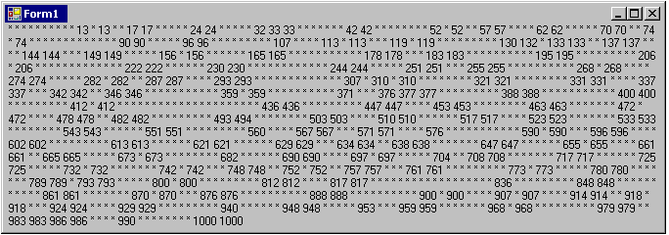
Without_Synchronisation
public delegate void mySetLabelTextDelegate(string myString);

public partial class Form1 : Form
{
private int commonCounter = 0;
Random R = new Random();

private void Form1_Load (object sender, EventArgs e)
{
Thread thread_1 = new Thread(action);
/// Thread thread_1 = new Thread(new ThreadStart(action));
thread_1.Start();

Thread thread_2 = new Thread(action);
//// Thread thread_2 = new Thread(new ThreadStart(action));
thread_2.Start();

Thread thread_3 = new Thread(new ThreadStart(action));
thread_3.Start();
}
void action()
{
while (commonCounter < 1000)
{
commonCounter++;
int temp = commonCounter;
if (R.Next(0, 3) == 0)
Thread.Sleep(1);
if (temp != commonCounter)
this.Invoke(new mySetLabelTextDelegate(mySetLabelText), commonCounter.ToString());
else
this.Invoke(new mySetLabelTextDelegate(mySetLabelText), "*" );
}
}
private void mySetLabelText(string myString)
{
label1.Text += myString + " ";
}
private void Form1_FormClosing(object sender, FormClosingEventArgs e)
{
System.Environment.Exit(System.Environment.ExitCode);
}
}
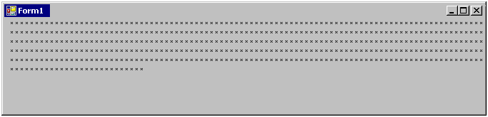
Monitor
public delegate void mySetLabelTextDelegate(string myString);

public partial class Form1 : Form
{
private int commonCounter = 0;
private Random R = new Random();

private void Form1_Load (object sender, EventArgs e)
{
Thread thread_1 = new Thread(action);
thread_1.Start();
Thread thread_2 = new Thread(action);
thread_2.Start();
Thread thread_3 = new Thread(action);
thread_3.Start();
}
void action()
{
while (objSimple.counter < 500)
{
Monitor.Enter(this);
commonCounter ++;
int temp = commonCounter;
if (R.Next(0, 3) == 0)
Thread.Sleep(1);
if (temp != commonCounter)
this.Invoke(new mySetLabelTextDelegate(mySetLabelText),
commonCounter.ToString());
else
this.Invoke(new mySetLabelTextDelegate(mySetLabelText), "*" );
Monitor.Exit(this);
}
}
private void mySetLabelText(string myString)
{ label1.Text += myString + " ";
}
private void Form1_FormClosing(object sender, FormClosingEventArgs e)
{ System.Environment.Exit(System.Environment.ExitCode);
}
}

Monitor_SimpleObect
public partial class Form1 : Form
{
private int commonCounter = 0;
private Simple mySimple = new Simple();

void action()
{
while (commonCounter < 500) {
Monitor.Enter(mySimple);
commonCounter++;
int temp = commonCounter;
if (R.Next(0, 3) == 0)
Thread.Sleep(1);
if (temp != commonCounter)
this.Invoke(new mySetLabelTextDelegate(mySetLabelText), commonCounter.ToString());
else
this.Invoke(new mySetLabelTextDelegate(mySetLabelText), "*");
Monitor.Exit(mySimple);
}
}
}

public class Simple
{
}
- - - - - - - - - - - - - - - - - - - - - - - - - - - - - - - - - - - - - - - - - -
Synchronization Monitor.Enter(myClass_Object) in memory

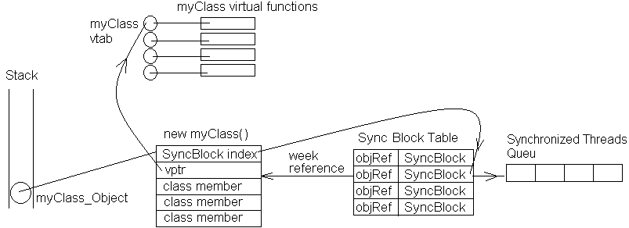

void action() Lock
{
while (commonCounter < 500)
{
lock (mySimple)
{
commonCounter ++;
int temp = commonCounter ;
if (R.Next(0, 3) == 0)
Thread.Sleep(1);
if (temp != commonCounter )
this.Invoke(new mySetLabelTextDelegate(mySetLabelText),
commonCounter.ToString());
else
this.Invoke(new mySetLabelTextDelegate(mySetLabelText), "*");
}
} }
- - - - - - - - - - - - - - - - - - - - - - - - - - - - - - - - - - - - - - - - - -

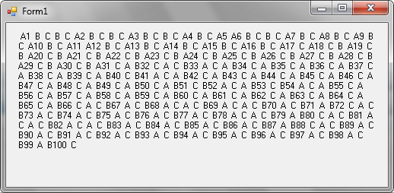

void action() Monitor_TryEnter
{
while (commonCounter < 200)
{
if (System.Threading.Monitor.TryEnter(mySimple)) {
commonCounter++;
Thread.Sleep(1);
this.Invoke(new mySetLabelTextDelegate(mySetLabelText), +
Thread.CurrentThread.Name + commonCounter.ToString());
System.Threading.Monitor.Exit(mySimple);
}
else
this.Invoke(new mySetLabelTextDelegate(mySetLabelText), " " +
Thread.CurrentThread.Name);
}
}

